Nutrition in plants
1.Name the essential pigment that absorbs light.
2.Can you name the gaseous raw material of photosynthesis.
3.If grana of a chloroplast are removed then, which of the reaction will not be carried out?
4.Name the gas that is produced as a by-product during photosynthesis.
5.What is the stored form of carbohydrates in plants and animals respectively?
6.What is the sequence of steps in photosynthesis? How is it different in desert plants and those in temperate regions?
7.What are the possible observations in the given setup?
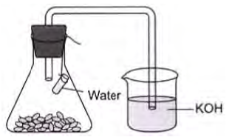
8.Leaves of a healthy potted plant are coated with Vaseline to block the stomata. Will this plant remain healthy for long? State three reasons to support your answer.
9.Mention the major events occur during photosynthesis.
10.What is common for cuscuta, ticks and leeches?

11.
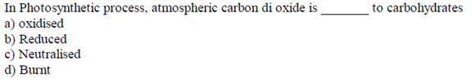
12.
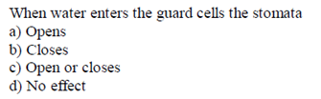
13.
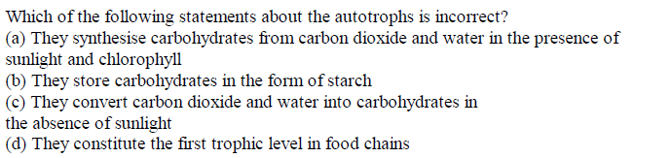
14.
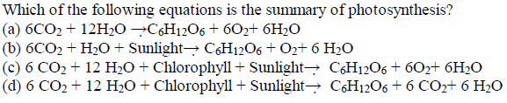
15.
